Domaine Systèmes Autonomes – DSAT301 Systèmes Embarqués

Specification of the functional and physical architecture
in SysML with Catia Magic (ex. Cameo Systems Modeler)
Quentin Cespèdes, Janette Cardoso, Mayssa Chebbi, Mourad Chibane
Marked Seminar

This marked seminar lasts 2 hours and is done in pairs.
During the BE, your teachers will come by with a marking sheet to see the answers to the questions. Realize the BE step by step. When you judge you have completed a step, ask the teacher to come and see what you have done.
Drop the model on the LMS at the end of the session. There is no work to take away, or report to submit after the session.
Note: you will need the text of the 1st exercise to remember certain manipulations (use cases, sequence diagrams, etc.). The package number (eg, 1.A) may change between previous BE models and the noted BE, but the package name will always be the same, eg "Use Cases and Scenarios".

Introduction
Useful information on Cameo and the model:
- To start the tool: in Windows, open the Catia Magic "Systems of Systems Architect" application Choose "Defaults". -- Select "Use a floating license": the server name is licence-w2k19.isae.fr and the port number is 1101.
- To load the model: Download the models from LMS; place the two .mzip files in a directory, and do not unzip them. From Cameo menu, "Open the project" (choose UAV_BE*.mdzip; the file SAMAREQ_Profile.mdzip is loaded automatically).
- When starting the tool, choose the “Systems Engineer” Perspective. You can also do it later from the menu Options -> Perspectives.
- Switch the language to English: Options-> environments -> general -> language -> English

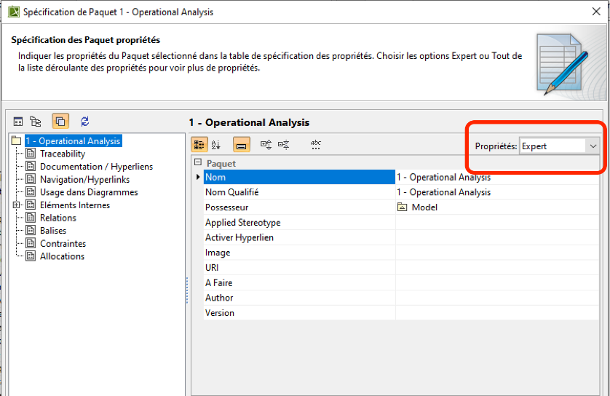
Figure SEQ Figure \* ARABIC 1. Element specification - Expert mode

2. Problem to be addressed
Specification: The Ministry of the Environment would like to call on your company to propose a solution to control and monitor the Pyrenean bear. These drones will be the property of the Occitanie-Pyrénées-Méditerranée Regional Council.
The tension that reigns between the Ariège breeders and the associations for the protection of this species leads the state to reimburse the shepherds up to the purchase price of the animals killed by the bears. In this context, it is requested to propose a solution that allows your autonomous drone to patrol around breeding areas and detect if one or more Pyrenean bears are in critical approach. The mission requirements are as follows:
- As the bear also moves at night, your solution must be able to detect the animal in the dark using an infrared light camera with recognition software.
- If a bear is detected, the drone must be able to modify its flight plan so that it follows it from a distance to assess the risk of approach.
- In the event that the bear crosses an alert line (position of the bear < 1km in relation to the flock) and the bear takes the direction of the flock:
  - Your drone must send an alert signal to the concerned shepherds.
  - Your drone must try to scare the bear

Note: When designing a system, we may have to do top-down and botton-up. Indeed, during the analysis of a SysML diagram, one may need to update or change other diagrams. In this BE what you are going to do: complete the context diagram, the use cases, then detail the "Avoid Bear Approach" case, return to the context diagram, etc.

Here is a visual representation:
Step 1 Bear is detected OUTSIDE the tracking perimeter: the system continue its mission

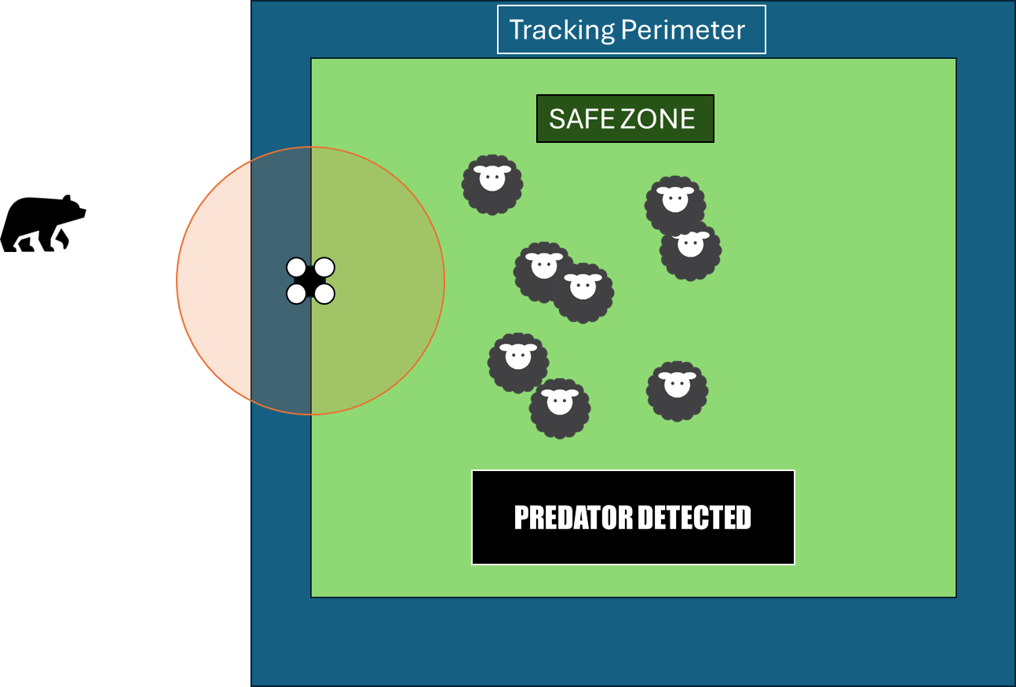

Step 2 Bear ENTER the tracking perimeter: the system track the bear from distance without interfering

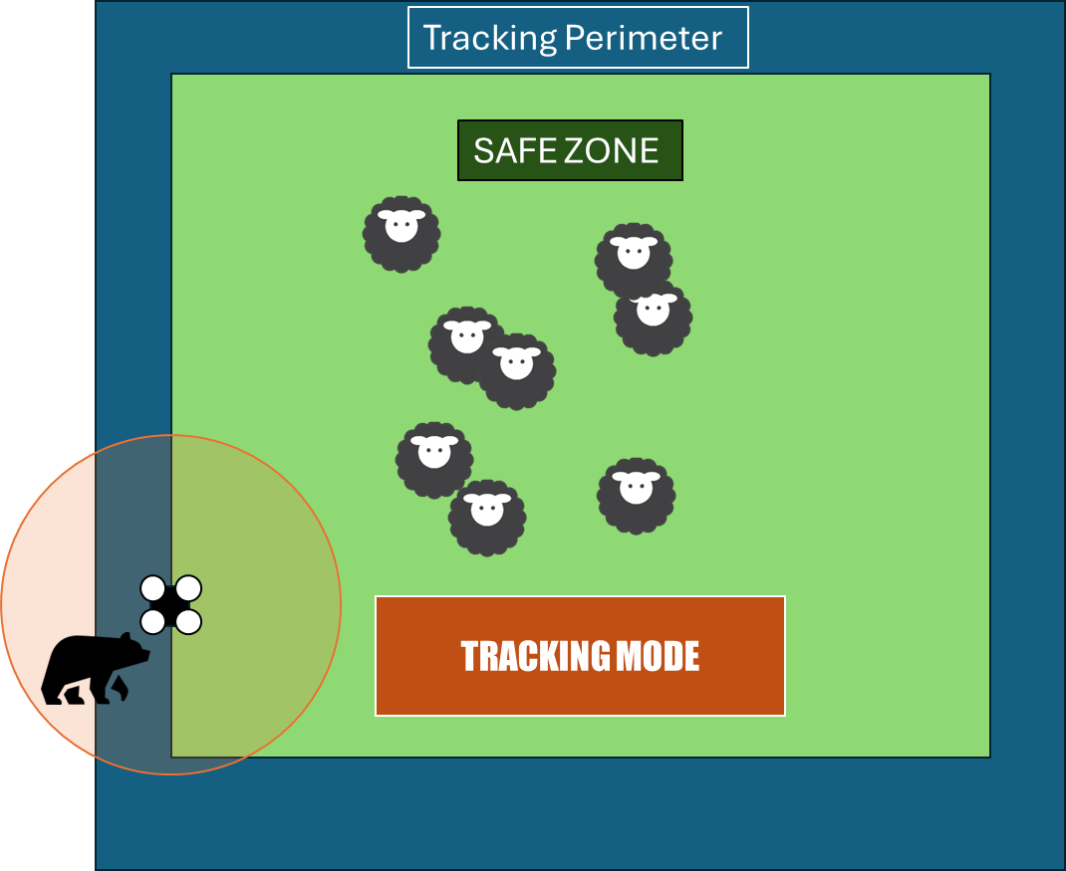

Step 3 Bear ENTER the Safe Area: the system trigger counter actions and warn the Shepperd

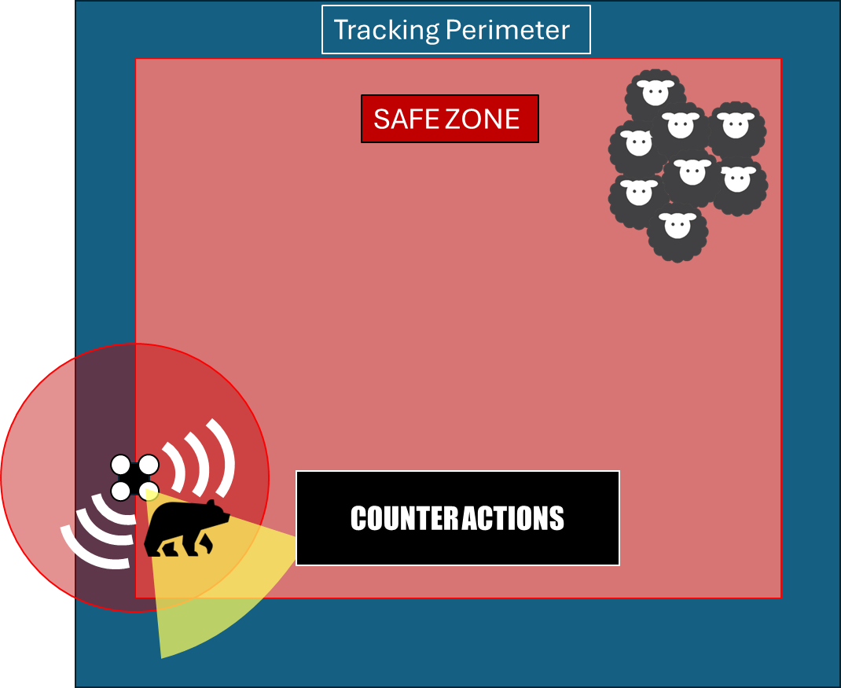

3. Tasks to be done:
Task 1: Complete the operational context diagram by adding the bear and connecting it to the SoI. Note that the bear (part) is already there, and the type already declares two ports that should be used. The specification contains enough information for you to understand what they are. When connecting them to the SoI, you will have to create the conjugated ports on the SoI side.
Exchanged flows between bear/SOI will be defined later (port arrows)

Tips: To switch to a bear icon select the dropped block name “bear” and click on the bar diagram “Display as Image”.
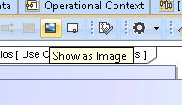

Tips 2: When connecting an existing port to a target part, Magicdraw automatically create a conjugated port type by the same interface

Task 2: Complete the use case diagram
- Add the "Bear" actor by dragging and dropping onto the diagram. This actor is already declared in the model in 1 - B Operational Breakdown/ Operational Elements.

- Create the use case “protect the sheeps from predators” then create the extension point in “surveillance of sheep in a safe zone area” use case and name it “Predator entering the safe zone”. Click on Create a new extension point (don’t tick the name in the window).
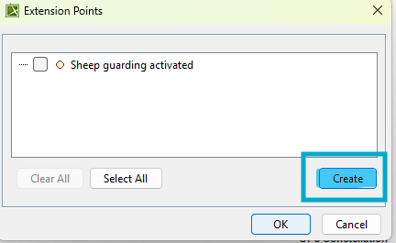
- Link the UC to the other elements, as seen in the previous exercise and lesson.

Question 0: Show tasks 1 and 2 to a teacher. (1 point)

Task 3: Creation of a Sequence Diagram in the "Protect the sheeps from predators" UC from the following scenario:

Description of scenario 1:
The drone receives an infrared signal from an animal on the ground. After analysis of this signal, it appears that the thermal and gestural signature of the animal corresponds to a bear. The drone calculates the position of the bear. The Bear enter the tracking perimeter, thus the SOI shall start tracking the predator. It turns out that the bear enter the Safe Area. The drone deploy counter action by sending an alert signal to the shepherd and tries to scare the bear away with sound and light.

Note: To create the sequence diagram (SD) describing the scenario, you may reuse as much signal as possible, but you will need new signals for messages entering or leaving the lifelines of the SD. You can first create the signals (question 1.0) then the SD (question 1.1) or vice versa. This can be an iterative process if you miss a signal, or a message in the SD. New physical signals should be placed in " B - Functional Data " Package which appears in “2 - Functional Analysis”.

Note2: Signals are only used for messages, as they describe an exchange, NEVER on reflexive messages that represent a behavior.

Question 1.0: What signals are needed to describe Scenario 1? Reuse the signal(s) as indicated Note 1 (if they do not exist, create them) (2 points)
……………………………………………………………………………………………………………………………………………………………… ……………………………………………………………………………………………………………………………………………………………… ………………………………………………………………………………………………………………………………………………………………

Question 1.1: In the case of use “Protect the sheeps from predators ", create the sequence diagram that specifies scenario 1. (3 pts)

Question 2: a) On the connectors previously created in task 2.1 (Operational Context diagram), indicate on which connectors the physical flows created in question 1.0. b) Update the context diagram following the new flow between the drone and the shepherd (see question 1.1) (2 points) ……………………………………………………………………………………………………………………………………………………………… ……………………………………………………………………………………………………………………………………………………………… ………………………………………………………………………………………………………………………………………………………………
Reminders:
- Port are a point of connection, and are typed by Interface Block
- Interface blocks are the interface contract defining what flow is provided/received, theses flow are represented by flow property (and shall be created).
- Flow property can be typed by signals to be consistent

Task 4: Modification of the functional architecture
Question 3: Create under “A - Functional architecture/Predator management” the new functions identified for UAV, when creating the Sequence Diagram, only consider the steps related to tracing. (1pt).
Question 4: Complete the State Machine diagram with the transition linked to predators management states (detected, tracking, counteraction), and the according signal (2 points)
Question 5: Take inspiration from sheep monitoring function, and by reusing the create functions (question 3), describe the activity diagram of “Monitoring Predator”. Adapt functions names, “define if sheep is leaving safe area” shall determine if the Predator is entering the tracking area (3 point)
BONUS Question 6: Complete the Activity diagram "Start Predator Tracking” in order to describe the tracking behavior and make the state machine progress automaticaly, reuse the function inside “tracking predator” package. (1 points).
Question 7: Simulate the State Machine diagram corresponding to the " SOI - Pasture Sentinel " function. The simulation must cover all the elements (2pt).

Task 5: Modification of the physical architecture
Open the block definition diagram (BDD) located in “3 – Physical Analysis / A – Physical Architecture”
Question 8: Propose a physical solution by adding new subsystems responding to the functions linked to “engage predator” (2pts).
Tip: Sometimes it's not useful to create a lot of new subsystems. Some features may be supported by existing subsystems, subject to modification on those. We are doing a “simplified” trade-off here: make or buy.
Task 6: Allocation of new functions
Question 9: Depending on your choices, allocate all new functions to newly created subsystems and/or to those that already exist (“C – Function Allocation” matrix in “2 – Functional Analysis /C – Traceability" (1pt).

